CV MATCHING & SCORING SYSTEM
MVP Product Specification · Phase 1
Internal AI Recruitment Decision-Support Platform · European & US Clients

Document Overview  Type Internal Technical Specification  Phase Phase 1 — MVP  Audience Product, Engineering, AI  Timeline 1 weeks  Phase 2 ATS Integration (All platforms)  What this system is NOT  - Not a chatbot  - Not a recommendation engine  - Not an ATS (Phase 2)  What this system IS  - Requirement-by-requirement scoring  - Evidence-traced, explainable shortlisting  - Recruiter decision-support tool | System Workflow Overview  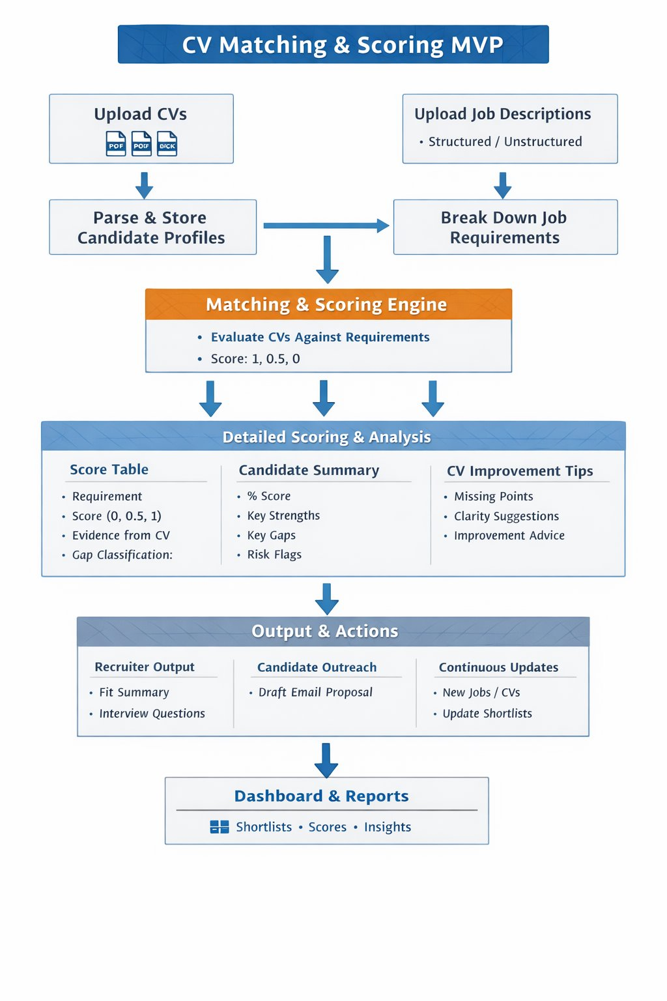

Internal document · Not for external distribution · MVP Phase 1

1. Product Goal
Build an internal AI-powered recruitment decision-support platform that helps recruiters score candidates against job requirements, produce explainable shortlists, and take action — all without inventing or assuming experience that is not in the CV.

This is not a chatbot. It is a structured scoring and evidence-tracing system.

Recruiters will use the system to:
- Upload CVs and job descriptions
- Automatically parse and structure information
- Score each candidate against each requirement individually
- Review evidence, gaps, risk flags, and improvement suggestions
- Generate recruiter summaries, interview questions, and outreach emails

2. User Roles
Recruiter | Admin
- Upload CVs and job descriptions  - View candidate matches and scoring  - Review shortlists and score breakdowns  - Export reports  - Send outreach emails | - Manage users  - Configure scoring logic and thresholds  - View all jobs and candidates  - Configure risk flag rules  - Configure ATS integrations (Phase 2)

3. Core MVP Modules

M1 | CV Upload & Parsing

Objective
Allow recruiters to upload CVs in PDF or DOCX format and convert them into structured, searchable candidate profiles.

Processing Flow
- User uploads file (PDF / DOCX)
- System stores original in cloud storage (S3)
- Parser extracts raw text
- LLM converts extracted text into structured candidate profile (JSON)
- Structured profile saved to PostgreSQL
- Candidate embeddings generated and stored in vector database

Candidate Profile Fields
Identity | Full name, email, phone, location
Professional | Current title, years of experience, seniority level
Skills | Technical skills, soft skills, tools & technologies
Work History | Company, role, dates, responsibilities (per role)
Education | Degree, institution, year
Certifications | Name, issuer, year
Other | Languages, domain expertise, employment type preference, work authorization

M2 | Job Description Upload & Requirement Extraction

Objective
Allow recruiters to upload or paste job descriptions and convert them into individual, scorable requirements.

Input Methods
- Paste free text
- Upload PDF or DOCX
- Manual form entry

JD Parsing Output
Job Metadata | Title, company, location, employment type, seniority
Skills Required | Technical skills, soft skills, tools / technologies
Experience | Years required, industry background, certifications
Education | Minimum education requirements
Requirements | Must-have requirements (mandatory), Nice-to-have (preferred / optional)

Requirement Breakdown — Example
Job: Senior Python Engineer
Each line becomes one independent scoring row:

Req 1 | 5+ years Python experience
Req 2 | Experience with Django
Req 3 | Experience with AWS
Req 4 | Experience with PostgreSQL
Req 5 | Experience with REST APIs
Req 6 | Strong communication skills
Req 7 | Experience working with European clients

Requirement Categories
- Mandatory — must be present; absence triggers risk flag
- Preferred — scored but not disqualifying
- Optional — bonus points only

4. Matching & Scoring Engine

4.1 Scoring Rules

Score | Meaning | Gap Class | Recruiter Action
1.0 | Clearly demonstrated — strong evidence | Strongly Demonstrated | No action needed
0.5 | Partially demonstrated or weak evidence | Partially Demonstrated | Clarify in CV
0.0 | Not mentioned or not shown | Clearly Missing | Flag as gap / reject

Important: If a Mandatory requirement scores 0, the system automatically raises a Risk Flag on that candidate regardless of total score.

4.2 Example Score Table

Requirement | Evidence | Score | Confidence | Gap Type
Python 5+ yrs | Python Engineer for 6 years | 1.0 ✓ | High | Clearly Met
Django | Django listed across multiple projects | 1.0 ✓ | High | Clearly Met
AWS | EC2 mentioned once only | 0.5 ~ | Medium | Partial
PostgreSQL | Not mentioned | 0.0 ✗ | Low | Missing

4.3 Confidence Logic
High Confidence | Explicit mention in CV. Multiple references across different roles or projects.
Medium Confidence | Mentioned once. Indirect or implied evidence.
Low Confidence | Weak wording. Unclear or context-inferred evidence only.

4.4 Score Calculation
Candidate Score % = (Total Candidate Points ÷ Total Possible Points) × 100

Example | Candidate total = 8.5 points out of 12 possible
Final Score | 8.5 ÷ 12 × 100 = 70.8%

4.5 Shortlisting Thresholds

Score Range | Match Level | Recommended Action
80% and above | Strong Match | Shortlist immediately
65% – 79% | Moderate Match | Review and consider
Below 65% | Weak Match | Reject or save for later

4.6 Risk Flags

Risk Flag | Trigger Condition | Action
Missing mandatory requirement | Hard block — candidate fails must-have check | Reject / Flag
Too few years of experience | Years in CV fall below minimum threshold | Flag for review
Missing location / work auth | Cannot confirm right-to-work | Request clarification
Missing leadership experience | Seniority requirement not evidenced | Flag for review
No evidence for key technology | Core tech not mentioned anywhere in CV | Flag or reject

4.7 LLM Evaluator — Reasoning Loop
The scoring engine does not make a single pass. It runs a structured multi-step reasoning loop per requirement to reduce hallucination and improve accuracy.

# | Step | What the evaluator does
1 | Read Requirement | Parse the individual requirement from the JD — type, threshold, and intent.
2 | Search CV | Locate all sections of the CV that could contain relevant evidence.
3 | Assess Evidence | Evaluate strength, recency, and explicitness of each piece of evidence found.
4 | Assign Score | Apply 0 / 0.5 / 1 scoring rule. Assign confidence level and gap classification.
5 | Self-Critique | Re-read the evidence and challenge the assigned score. Would a senior recruiter agree?
6 | Finalise & Cite | Lock the score and record the exact CV section used as evidence for traceability.

Why this matters
The self-critique step is what separates this system from a basic LLM prompt. It catches overconfident scores, forces evidence re-verification, and ensures the final output can withstand scrutiny from a senior recruiter reviewing the reasoning.

5. Candidate Analysis Output
Each candidate detail page contains five structured sections:

A | Section A: Candidate Summary Card  Name · Current title · Total score % · Match level · Years of experience · Key skills · Location · Availability

B | Section B: Detailed Requirement Scoring Table  Requirement · Score · Evidence from CV · Confidence level · Gap type · Notes

C | Section C: Key Strengths  Examples: Strong Python background, enterprise SaaS experience, distributed teams

D | Section D: Key Gaps  Examples: No AWS architecture evidence, no PostgreSQL, no European client experience

E | Section E: CV Improvement Suggestions  Based strictly on clarity and wording improvement. System never invents experience.

6. Recruiter Output Module

6.1 Recruiter Fit Summary
Auto-generated paragraph explaining why the candidate is or is not a fit.
Example:
"This candidate is a strong match for the Senior Python Engineer role due to strong Python, Django, REST API, and SaaS experience. Main concerns are limited AWS evidence and no explicit PostgreSQL mention."

6.2 Suggested Interview Questions
Generated automatically from gap analysis. Each question targets a specific scoring gap.
- Can you explain your experience with AWS services beyond EC2?
- Have you used PostgreSQL in previous projects? Can you give an example?
- Tell us about your experience working with distributed or international teams.

6.3 Recruiter Decision Actions
Shortlist | Move candidate to shortlist for this job
Reject | Mark as rejected with optional note
Save for Later | Park candidate for future roles
Add Notes | Free-text recruiter notes attached to candidate
Compare | Side-by-side comparison of two or more candidates

7. Candidate Outreach Module

System generates a personalised email draft for each candidate based on their match results.

Contents | Candidate name · Role name · Why they are a fit · Invitation to discuss
Editable | Recruiter can edit before sending
Templates | Save and reuse outreach templates
Variables | Dynamic personalisation fields pulled from candidate profile

8. Continuous Matching Engine

The continuous matching engine is the first agentic component of the system. It does not wait for human instruction — it monitors, decides, acts, and reports on a defined schedule.

Monitor → Decide → Act → Report

Scenario 1 — New CV Added | Scenario 2 — New JD Added
- Detects new CV in the system  - Decides which open JDs are relevant using vector similarity  - Runs full scoring pipeline against matched JDs  - Updates candidate ranking tables automatically  - Notifies recruiter only if score exceeds threshold | - Detects new JD in the system  - Retrieves all stored candidates from vector store  - Scores all candidates against new requirements  - Produces ranked shortlist automatically  - Notifies recruiter with top matches and risk flags

MVP Batch Mode | Scheduled every 1 hour. Manual 'Run Matching' button available.
Agent Behaviour | The engine acts without being asked — it monitors for new data, runs scoring, and updates shortlists autonomously.
Escalation Rule | Recruiter is only notified when action is needed: high match found, risk flag raised, or shortlist rank changes significantly.
Future Phase | Real-time event-driven matching. Webhooks from ATS trigger immediate scoring on new candidate or job activity.

Trigger Sources
The matching engine responds to three trigger types. Triggers 1 and 2 are available in MVP. Trigger 3 activates when any ATS connector is configured.

# | Trigger | Event | Available
1 | Manual Upload | Recruiter uploads CV or JD directly into the system | MVP — Phase 1
2 | Scheduled Batch | Hourly job re-runs matching across all new data since last run | MVP — Phase 1
3 | ATS Webhook | Any connected ATS fires an event: candidate applied, job posted, stage changed | Phase 2 — ATS connector

9. Dashboard & Reports

9.1 Dashboard Widgets
Total Candidates | Count of all stored candidates
Total Jobs | Count of all active job descriptions
Uploaded Today | New CVs and JDs added in the last 24 hours
Average Match Score | Mean score across all active matches
Top Candidates by Score | Ranked shortlist across all open jobs
Jobs with Most Candidates | Jobs with highest volume of matches
Risk Alerts | Candidates with mandatory gaps or risk flags

9.2 Reports
- Candidate Match Report — full scoring breakdown per candidate
- Job Match Report — ranked shortlist per job
- Missing Skills Trends — most common gaps across all candidates
- Top Skill Demand Report — most requested skills across all jobs
- Export to PDF / CSV

10. MVP Screens

# | Screen | Purpose
1 | Login Screen | Auth entry point
2 | Dashboard | KPIs, alerts, top candidates
3 | Upload CV | File upload with progress
4 | Upload Job Description | Paste, upload or form entry
5 | Candidate List | Filterable, sortable candidate index
6 | Job List | All active job descriptions
7 | Candidate Match Detail | Full score table, evidence, gaps
8 | Job Match Detail | Ranked shortlist for a job
9 | Comparison Screen | Side-by-side candidate comparison
10 | Outreach Email | Draft, edit, send personalised email
11 | Reports | Export match and skill trend reports
12 | Admin Settings | Users, scoring config, ATS setup

11. Agentic AI Roadmap

The MVP is the data and scoring foundation that an agentic system runs on. Without accurate per-requirement scores, traceable evidence, and structured profiles, agents have nothing reliable to act on. The phases below describe how autonomous AI capabilities layer on top of the MVP.

ATS Integration | Platform Expansion
- Connect any ATS via abstraction layer  - Pull candidates automatically from connected ATS  - Pull job descriptions automatically  - Push shortlist scores and tags back to connected ATS  - Trigger matching on ATS webhook events  - First connector: Teamtailor (reference implementation) | - LinkedIn profile parsing  - Role-specific scoring templates  - Interview feedback scoring  - Candidate comparison matrix

Agentic AI Roadmap

Agentic AI means the system pursues goals autonomously — planning, acting, checking results, and adapting without a human in the loop at every step. The table below maps each agent to the MVP component it extends.

# | Agent | What it does autonomously | Extends MVP module
1 | Ingestion Agent | Monitors email, LinkedIn, ATS. Pulls CVs and JDs without manual upload. | Module 1 & 2
2 | Enrichment Agent | Verifies claims, cross-references certifications, flags CV inconsistencies before scoring. | Module 1 — CV Parser
3 | Requirement Agent | Infers implicit requirements from JD context. Proposes additions to recruiter for confirmation. | Module 2 — JD Parser
4 | Scoring Agent | Runs the 6-step reasoning loop. Self-critiques scores. Re-reads CV sections when confidence is low. | Section 4 — Scoring Engine
5 | Shortlist Agent | Re-ranks candidates as new CVs arrive. Explains why rankings change. Sends daily digest to recruiter. | Section 4 — Shortlisting
6 | Outreach Agent | Sends email, tracks replies, follows up after 3 days, escalates to recruiter on response. | Section 7 — Outreach
7 | Gap Remediation Agent | Messages candidates to clarify ambiguous gaps before human review. Resolves 'poorly written' cases. | Section 5 — Gap Analysis
8 | ATS Sync Agent | Manages bidirectional sync with any connected ATS via the abstraction layer. Reconciles mismatches. Archives closed roles automatically.

Human-in-the-Loop Controls
Agents require clear rules for when to act autonomously and when to stop and ask. These are configured by Admin in the settings layer.

Agent acts autonomously | Agent pauses for recruiter
- Run scoring on new CV or JD  - Update shortlist rankings  - Send follow-up outreach email  - Sync scores to ATS  - Archive closed job roles | - Reject a candidate  - Send first outreach email  - Modify scoring thresholds  - Override a risk flag decision  - Shortlist a candidate with risk flags

12. ATS Integration Architecture

The system is designed to be ATS-agnostic. Rather than building a direct integration with one provider, a standardised abstraction layer sits between your scoring system and any ATS. Each ATS connects through a thin adapter that translates its own data format into the system's standard schema.

Any ATS → Connector Adapter → Abstraction Layer → Scoring System

12.1 Architecture Design

# | Layer | What it does | Built by
1 | Inbound API | Webhook receiver and REST endpoint. Any ATS that can POST data can connect. Accepts candidate objects, job objects, and status updates. | Your system (once)
2 | Connector Adapter | Thin translation layer per ATS. Maps each ATS's field names and formats to your standard schema. One adapter per ATS provider. | Per ATS (small)
3 | Standard Schema | Normalised candidate and job objects. All downstream scoring logic reads from this schema only — never from raw ATS data. | Your system (once)
4 | Outbound API | Pushes scores, shortlist decisions, tags, and notes back to the connected ATS in its native format via the adapter. | Your system (once)
5 | Connector Registry | Admin UI lists all available connectors. Recruiter enables or disables ATS connections. Credentials stored securely per connector. | Your system (once)

Internal document · MVP Phase 1 · Not for external distribution

